WIX

https://editor.wix.com/html/editor/web/renderer/edit/c3201d46-3eef-4cea-a863-599141f1aadf?metaSiteId=91c34d57-f9dc-41c6-a78d-d5971bdde54a

Figure 1: The home page of WIX website

Figure 2: The New Arrivals and Collections of the products

Figure 3: The Collections Sneakers

Figure 4: The Last page of the main page

Figure 5: The first part of category page

Figure 6: The last part of the category page

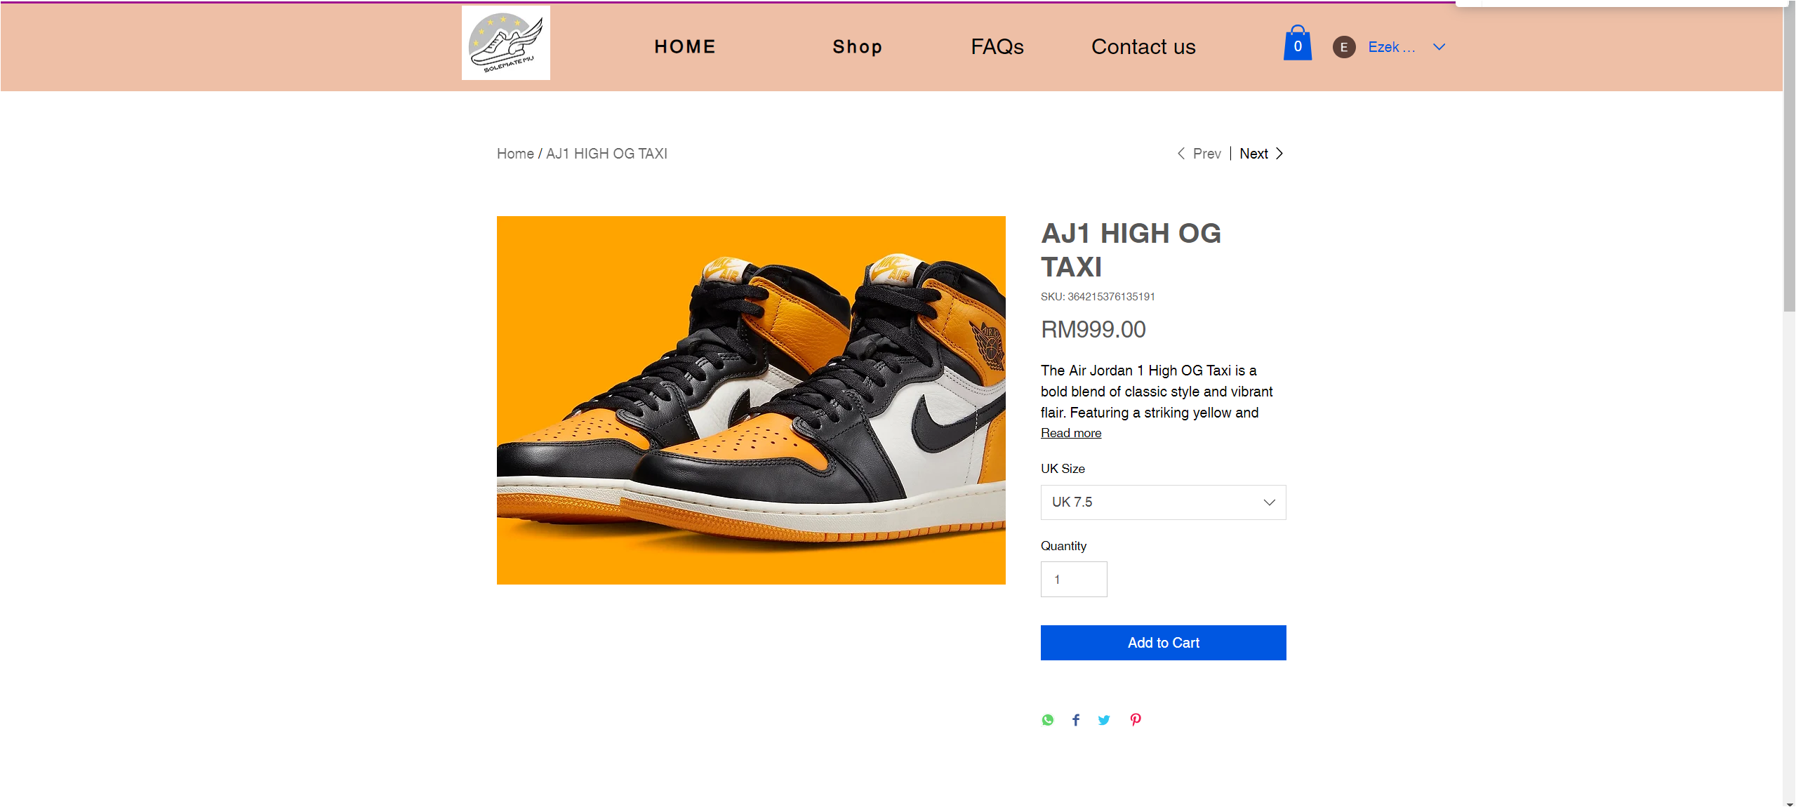

Figure 7: The First part of the AJ1 HIGH OG TAXI product page

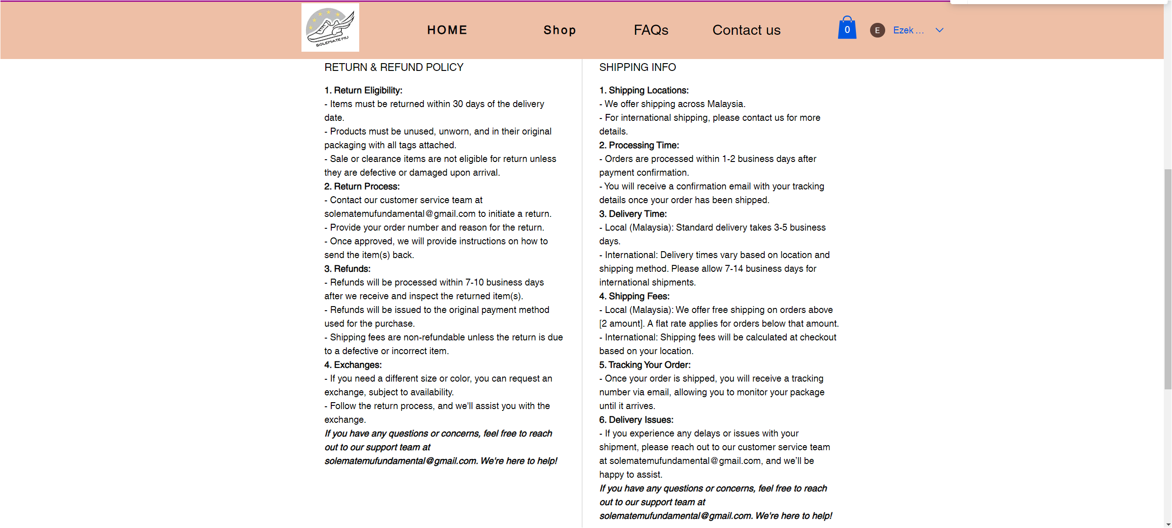

Figure 8: The second part of the AJ1 HIGH OG TAXI product page

Figure 9: The last part of the AJ1 HIGH OG TAXI product page

Figure 10: The first part of the AJ1 HIGH OG RED product page

Figure 11: The second part of the AJ1 HIGH OG RED product page

Figure 12: The last part of the AJ1 HIGH OG RED product page

Figure 13: The first part of the AJ1 HIGH OG MOCHA product page

Figure 14: The second part of the AJ1 HIGH OG MOCHA product page

Figure 15: The last part of the AJ1 HIGH OG MOCHA product page

Figure 16: The first part of the AJ1 HIGH OG NAVY product page

Figure 17: The second part of the AJ1 HIGH OG NAVY product page

Figure 18: The last part of the AJ1 HIGH OG NAVY product page